|  |  |
| --- | --- |
| **Project Case** |  |
| COMP7116 | COMP7116001 | COMP7116016  Computer Vision |
| **Computer Science** | **O232-COMP7116-JK06-00** |
| ***Valid on*** *Odd Semester 2022/2023* | **Revision 00** |

1. Seluruh kelompok tidak diperkenankan untuk:

*The whole group is not allowed to:*

* + - Melihat sebagian atau seluruh proyek kelompok lain,

*Seeing a part or the whole project from another groups*

* + - Menyadur sebagian maupun seluruh proyek dari buku,

*Adapted a part or the whole project from the book*

* + - Mendownload sebagian maupun seluruh proyek dari internet,

*Downloading a part or the whole project from the internet,*

* + - Mengerjakan soal yang tidak sesuai dengan tema yang ada di soal proyek,

*Working with another theme which is not in accordance with the existing theme in the matter of the project,*

* + - Melakukan tindakan kecurangan lainnya,

*Committing other dishonest actions,*

* + - Secara sengaja maupun tidak sengaja melakukan segala tindakan kelalaian yang menyebabkan hasil karyanya berhasil dicontek oleh orang lain / kelompok lain.

*Accidentally or intentionally conduct any failure action that cause the results of the project was copied by someone else / other groups.*

1. Jika kelompok terbukti melakukan tindakan seperti yang dijelaskan butir 1 di atas, maka **nilai kelompok** yang melakukan kecurangan (menyontek maupun dicontek) akan di – **NOL** – kan.

*If the group is proved to the actions described in point 1 above, the score of the group which committed dishonest acts (cheating or being cheated) will be “Zero”.*

1. Perhatikan jadwal pengumpulan proyek, segala jenis pengumpulan proyek di luar jadwal tidak dilayani.

*Pay attention to the submission schedule for the project, all kinds of submission outside the project schedule will not be accepted.*

1. Bila Anda tidak membaca peraturan ini, maka Anda dianggap telah membaca dan menyetujuinya.

*If you have missed to read these regulations, so you are considered to have read and agreed on it.*

1. Persentase penilaiaan untuk matakuliah ini adalah sebagai berikut:

*Marking percentage for this subject is described as follows:*

|  |  |  |
| --- | --- | --- |
| **Tugas Mandiri**  *Assignment* | **Proyek**  *Project* | **UAP**  *Final Exam* |
| 40% | 60% | - |

1. Software yang digunakan pada matakuliah ini adalah sebagai berikut:

*Software will be used in this subject are described as follows:*

|  |
| --- |
| **Software**  *Software* |
| OpenCV 4.6.0.66  Python 3.7.6  SciKit 0.23.1  Visual Studio Code |

1. Ekstensi file yang harus disertakan dalam pengumpulan tugas mandiri, proyek, dan uap untuk matakuliah ini adalah sebagai berikut:

*File extensions should be included in assignment, project, and final exam collection for this subject are described as follows:*

|  |  |  |
| --- | --- | --- |
| **Tugas Mandiri**  *Assignment* | **Proyek**  *Project* | **UAP**  *Final Exam* |
| PY | PY | - |

## Soal

*Case*

**Jrake Khronos**

**Jrake Khronos** is a new application that currently being developed by **BAKcompany**. This company focus on developing application with **Artificial Intelligence** concept,especially **Computer Vision**. **Jrake Khronos** needs to add a new computer vision feature to some applications which will be developed. This feature will allow the applications to recognize every **actor** and actress based on **profile** **image** with **single face**. Therefore, as a programmer of **BAKcompany**, you are asked to create that feature using **Python programming language** and **OpenCv Library**.

* **Dataset Description**

The given dataset contains **training dataset** consist of **7 - 20 profile images of** **each actor** and **actress** that already uploaded from the applications and **testing images** consisting of **5** **random actor**’**s** and **actress’s profile images**.

* **Get Path List**

The directories of the given **training dataset** will be stored into a **list** containing the **names of directories**. This list will also be used as the **labels** of the training images.

* **Get Class id**

The **image** from the **train dataset** will be **stored** into a **list** and every class will have an **image class name based on its sub-directories**.

* **Detect Face and Filter**

**Faces** inside the **training** **images** will be **detected** and stored into a **list** **of** **images**. The **position** and **size** of **detected** **face** will also be stored into a **list of rectangles**. You also need to **filter** the training images if there are **no face or more than one face detected**.

* **Train**

The **list** of **face** images will be used to **train** the **face recognizer**.

* **Get Test Image Data**

The **image** from test **dataset** will be **loaded** and **stored** into a **list of images**.

* **Predict**

The **list** of **testing images** will be predicted to **produce** the **prediction** **result** based on **trained** **recognizer**.

* **Draw Prediction Result**

The prediction **results** which consist of the **predicted names** and **face location** of the actor will be **drawn** to every single test image.

* **Combine and Show Result**

**List** of **testing images** that has been drawn will be **combined** into a **single image** with a condition that all of it must be **resized** with **350 x 350 px**. After being combined, **show** the **final image result**.

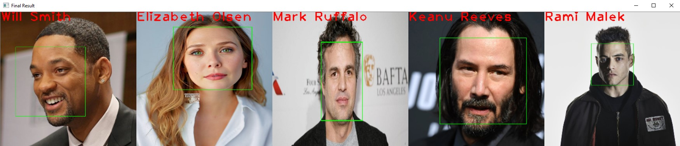

**Figure 1. Final Result**

**Guidelines:**

1. **All** the **steps mentioned in the case** should be **put** in the **corresponding function** in the **template**. **All codes written** **outside** the **corresponding function** will **not be marked**.
2. Do not **modify** or **erase** **any** **codes** in the **template**.
3. Do not **modify** or take **other images** as the **dataset**.

**Reference:**

* + - The dataset is obtained from Google Image